How To Read Research Reports Cheat Sheet
The Local Intelligence Report:
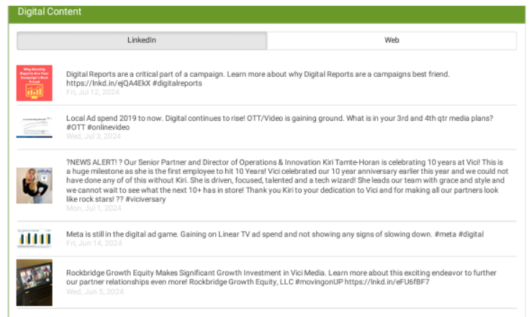
Digital Content shows snippets of postings that the client has done that have been found across the web.

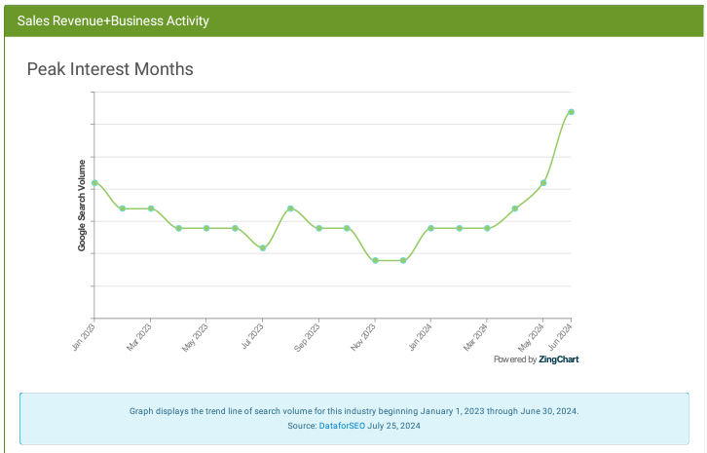
Peak Interest Months show INTEREST based on number of keyword searches related to the category of business the client is in.

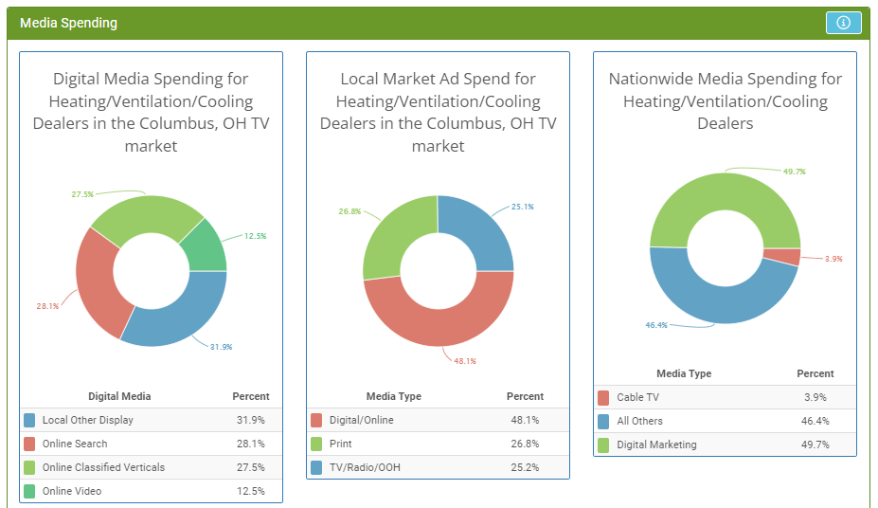
The Digital Media Spending chart shows a breakdown of digital media spending on digital for an industry in a chosen TV market.
The Local Market Ad Spend chart shows ad spending for an industry in a chosen TV market. The categories provided by BIA Advisory Services are: Digital/Online, Print, All Others. Specific media in each of these categories include:
Digital/Online:
TV Digital
Radio Digital
Internet Yellow Pages
Newspaper Digital
PC/Laptop
Mobile
Email
TV OTT
Print:
Print Yellow Pages
Magazines Print
Newspaper Print
All Others:
TV OTA
Cable TV
Direct Mail
Out of Home

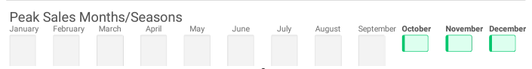
Peak Sales Months/Seasons shows the peak months for SALES REVENUE for this client’s type of business.

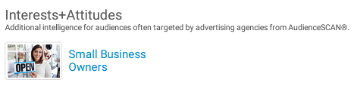
Interests + Attitudes is an additional report you can request from us that will show you what the client’s target audiences’ marketing preferences are.

The Digital Audit Report:
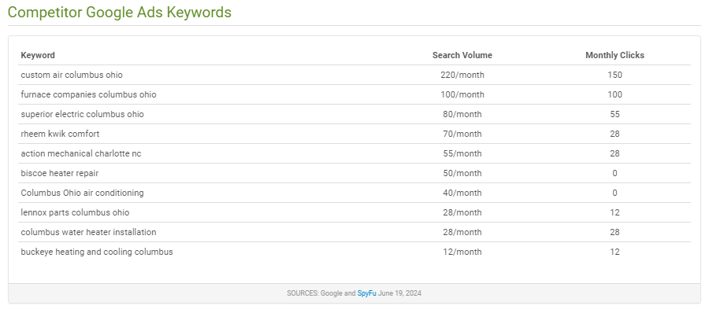
This table lists the top paid keyword phrases shared by this business and the Top Organic Competitors. Search Volume is the estimated number of times each key word is searched per month. Monthly Clicks is the estimated number of times users have clicked on a result after searching with those keywords.
This rating shows how well the advertiser's digital advertising efforts align with the digital advertising that influences their target market. We've ranked on a scale 1-5 (5 is best) at the top of the report. The target market (audience) is either based on lifestyle interest, profession, or in most cases, their intent to purchase/pay for a product or service in the next 12 months.
Display ads, text ads and where online display ads have recently run, are provided by AdBeat. AdBeat compiles new data every day from 100+ of the leading advertising networks plus many of the largest volume websites where advertisers can buy directly.
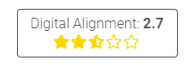

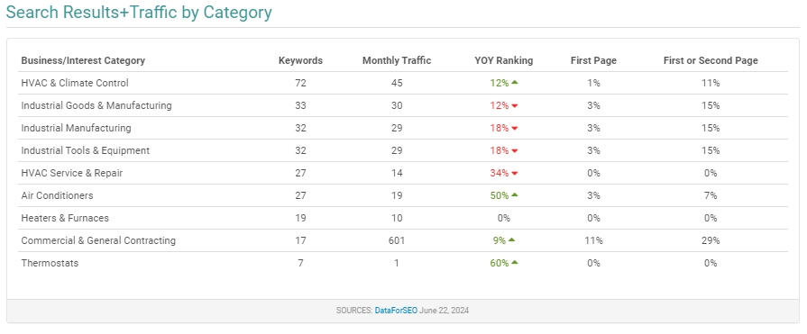
This table (if available) will provide you with Google product or service categories that include keywords the domain ranks for in search.
Business/Interest Category: Google's product and service categories for which the domain has ranked
Keywords: Total number of organic keyword combinations that would contain the domain
Monthly Traffic: Estimated organic monthly traffic to the domain calculated as the product of CTR (click-through-rate) and search volume values of all keywords in the category that the domain ranks for
YOY Ranking: After examining the Google rankings of all keyword combinations, this indicates the overall trend of whether the domain is moving up or down in the rankings in that category
First Page: The percentage of organic searches for the category where the domain was displayed on the first page of results (positions 1-10 on the screen).
First or Second Page: The percentage of organic searches for the category where the domain was displayed on the first or second page of results (positions 1-20 on the screen).

The Digital Audit Report: (Continued)

TOP 10 ORGANIC SEARCH KEYWORDS BY VOLUME
Search engine optimization data is provided by the search engines themselves and SEMrush. Data is updated monthly, with only the most common keywords being updated more frequently.
GOOGLE ORGANIC SEARCH TRAFFIC TRENDS
Traffic to the advertiser's website generated over time from Google search results that are unpaid and "natural" generally organized by relevancy, popularity, and common usage.
TOP ORGANIC COMPETITORS
This table shows the top organic competitors that rank for many of the same keywords that this business ranks for. These may or may not be local competitors. It's based solely on the keywords rankings. The Shared Ranking Keywords column shows the count of unique keywords that this domain and your domain both rank for.
COMPETITOR ORGANIC KEYWORDS
This table lists the top organic keyword phrases shared by this business and the Top Organic Competitors. Search Volume is the estimated number of times each key word is searched per month. Monthly Clicks is the estimated number of times users have clicked on a result after searching with those keywords.
MAP SEARCH RESULTS
If available, the two maps displayed are samples of the results users may see when searching for the business using online or mobile mapping application from Apple and Google. For example, using a mobile device a user may search by saying "Hey Siri" or "OK, Google".
PEOPLE SEARCHING FOR THIS BUSINESS ALSO SEARCHED FOR
If available, this section will show alternative keywords people have used in Google that have produced similar search results.

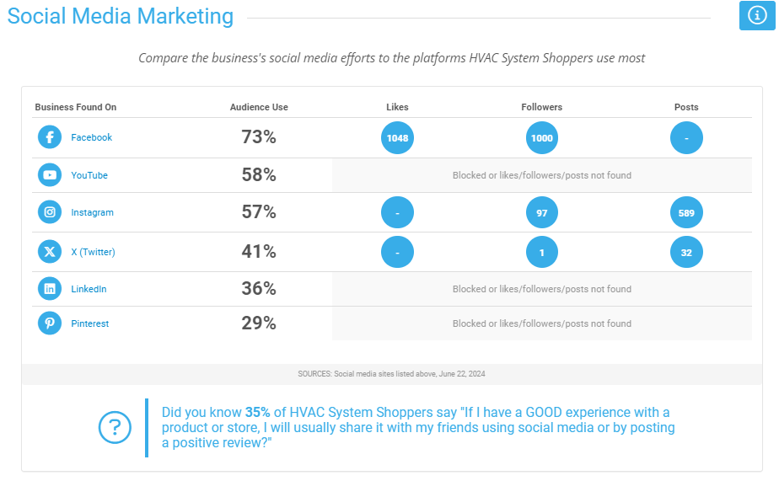
This section shows how well the prospect's presence on social media networks aligns with the social media used by their target market (audience). AdMall will display all the major social media platforms where we were able to find a presence for this business. AdMall makes efforts to find additional information such as Likes, Followers and the number of Posts. However, this information is not always available or the social media platform has blocked access to it.
If a page/channel for the prospect's business is not found, it may not exist or could not be easily found. This is a sales opportunity for your social media services. Note that a business/company page (or channel) is different than a user account.
YouTube search results shows a sampling of what appears first when people search YouTube for this advertiser.

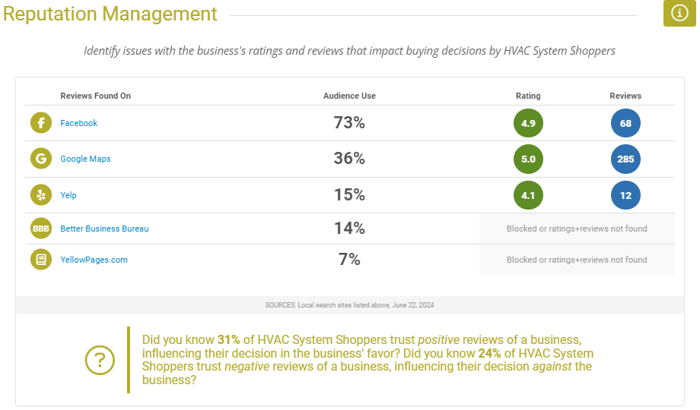
This section shows how well the prospect's online reputation aligns with the review sites used by their target market (audience). Up to seven of the top sites used by their target customer to search for local business information in the past six months is displayed on the left.
The number of reviews and aggregate review score for each site is displayed on the right. If the prospect's business listing could easily be found on the site, a checkmark is displayed on the far right. Otherwise, an X is displayed. Checkmarks are displayed in color based on their reviews.
Green: Very Good to Excellent
Gold: Average to Good
Red: Below Average
Gray: No reviews found
An overall Reputation Score based on all found ratings and reviews is displayed at the top of this report on a 10 point scale (0 is poor, 10 is excellent).
Any red or gray checkmarks, low scores, unresolved complaints or comments not addressed are a warning sign that your reputation management services are needed.

DESKTOP SPEED SCORE
This metric measures the speed of the business owner's website on a scale of 0 (poor performance) to 100 (optimal performance). A site that loads slowly is a sales opportunity for website development as it risks losing impatient customers. Bullet point suggestions for improvement are provided by Google. Use these to get the conversation started if you are selling website development services.
MOBILE SPEED SCORE
This metric measures the speed of the business owner's website as it appears on a mobile device (smartphone or tablet). The score is displayed on a scale of 0 (poor performance) to 100 (optimal performance). Also see the screenshots of their website as viewed on a tablet and a smartphone at the top of this report.
MOBILE FRIENDLY CHECK
This is a check run through Google's Mobile-Friendly Test where it is determined whether the site is easily loaded and usable on a mobile device.
SEO OPTIMIZATION
This check ensures that a web site is optimized for search engine results ranking according to Google.
SAFETY AND USER EXPERIENCE
This check scores the web site in regards to best practices in trust and safety (technologies in use contain no known vulnerabilities), user experience and browser compatibility.
ACCESSIBILITY
This score indicates opportunities to improve the usage of ARIA on the web site which may enhance the experience for users of assistive technology, like a screen reader. Only a subset of accessibility issues can be automatically detected so manual testing is also encouraged.

The Presentation:
The PowerPoint Presentation deck is a combination of info from the above two reports. It is client facing (unlike the other two reports) and all you need to do is add your logo or background. Have this cheat sheet with you when you present it to the client/prospect so you can answer questions.

In addition to these 2 reports and the Presentation you may also receive an Audience Scan report and a Hot Zips report.
Audience Scan Report:
This report shows you the marketing preferences of the target audience of the client’s business, as well as non-advertising preferences. Digital products are highlighted. The responses are based on a region not a specific geo. It will say on the report what region of the country it represents or if it is a national audience. This report is self-explanatory.
Hot Zips Report:
As the name implies, this report ranks the top zip codes where the target audience of the client, resides. It will also show a map of the geography and a pinpoint of where the client’s location is. This is great information to have to help the client decide how to geographically target their digital campaigns. The geography for this report can be city, metro, dma, or counties.

